Task 2: Performance Analyzer Documentation
Objective: To optimize the Power BI report and improve its overall performance and user experience using the built-in Performance Analyzer feature.

Activities Performed:
- Tool Initialization: Navigated to the Optimize tab (also accessible via the View tab in older versions) on the Power BI Desktop ribbon and opened the Performance Analyzer pane.

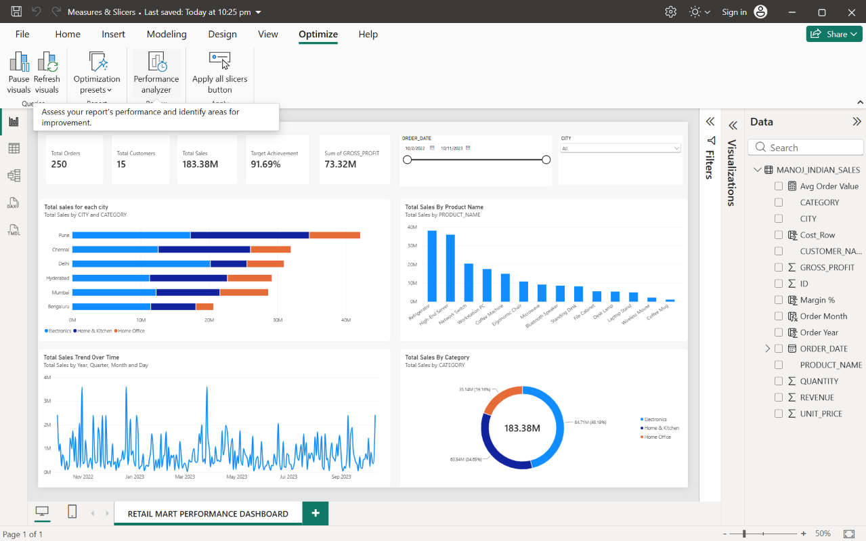

- Performance Tracking: Clicked Start recording within the pane to actively monitor and capture the rendering metrics of the dashboard in real-time.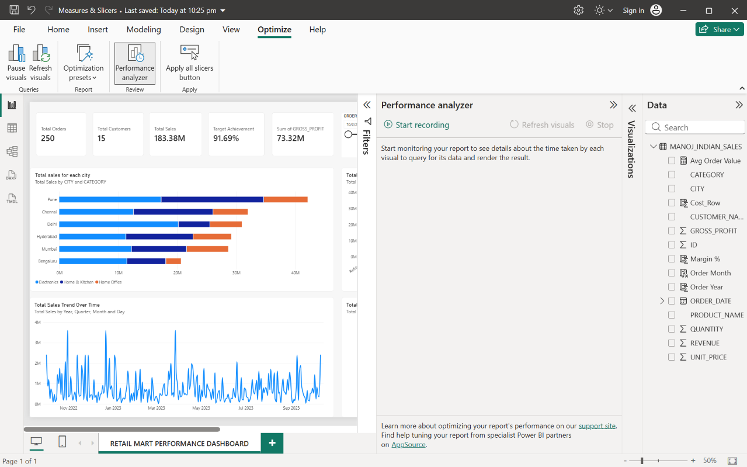
- Execution: Clicked Refresh visuals to force a complete reload of the report page. This action triggered all DAX measures and backend queries to recalculate from the Snowflake dataset.
Before Refresh:
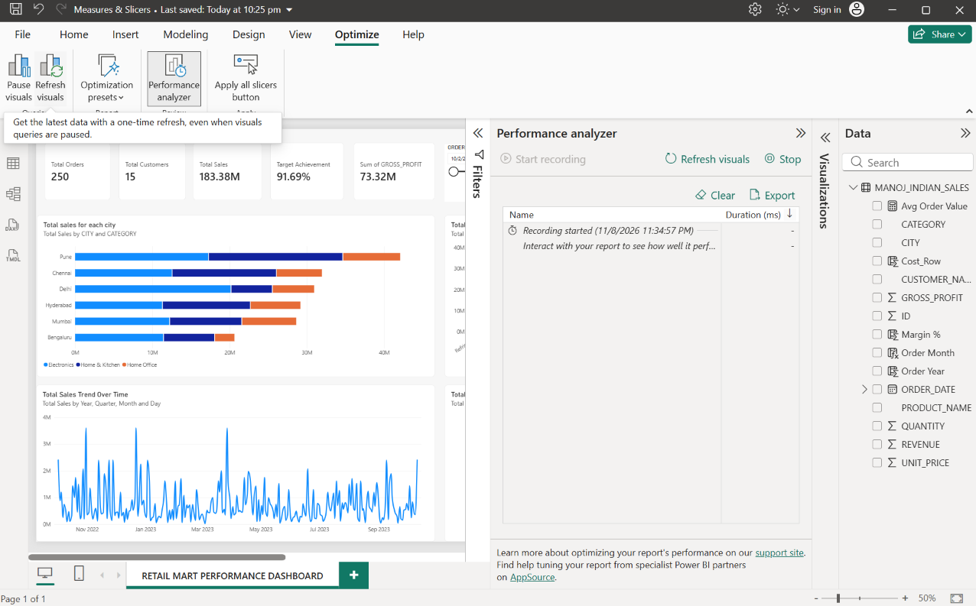

After Refresh:
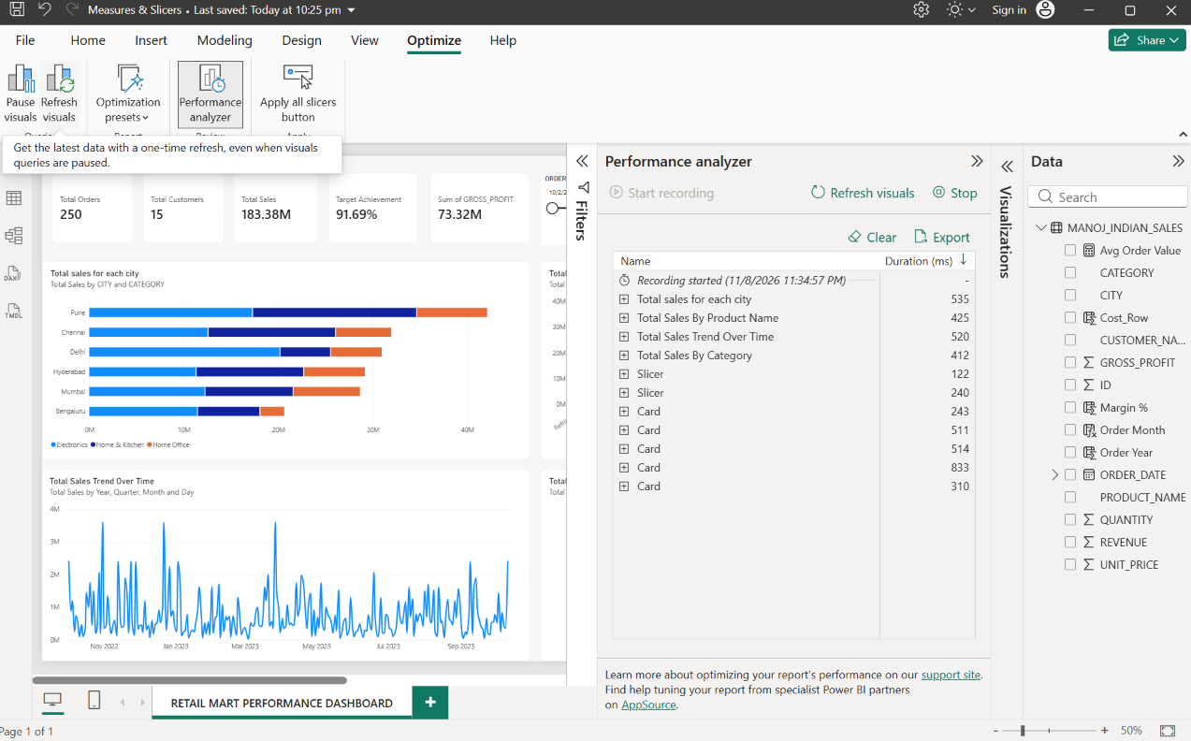

- Metric Analysis: Analyzed the execution logs generated by the analyzer, reviewing the exact time taken (in milliseconds) for individual visuals to load and render on the canvas.
For example, the Slicer took 240 ms, and the KPI Cards loaded in a range of 243 ms to 833 ms.

- Bottleneck Identification: Evaluated the breakdown of load times (DAX query duration vs. visual display duration vs. other processes) to identify which specific visuals took the longest to load.
In this report, one of the KPI Cards took the longest to load at 833 ms, making it the primary bottleneck. However, because all visuals rendered in under 1 second (1000 ms), the dashboard is highly optimized and requires no further DAX reduction.

